Mental Health Dataset

Data Cleaning/Normalization.
I will perform quality control by reviewing the dataset and addressing the following errors commonly found in data files.

Removal of duplicates
I decided to run a duplicate-check across all columns. Person_ID is the column that should be unique. The rest of the columns were numerical in nature or had commonly shared string values, such as Occupation, that one would expect to have recurring values. Given that, I used the .drop_duplicates function targeting the Person_ID column, keeping the first occurrence and dropping any subsequent occurrences. In my output section you will see that there are 0 duplicates in the Person_ID column

Code:
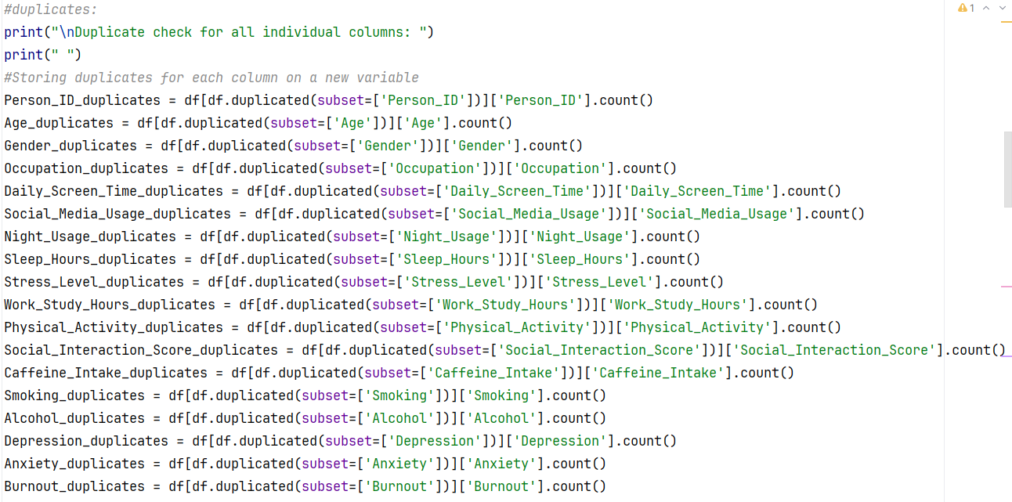
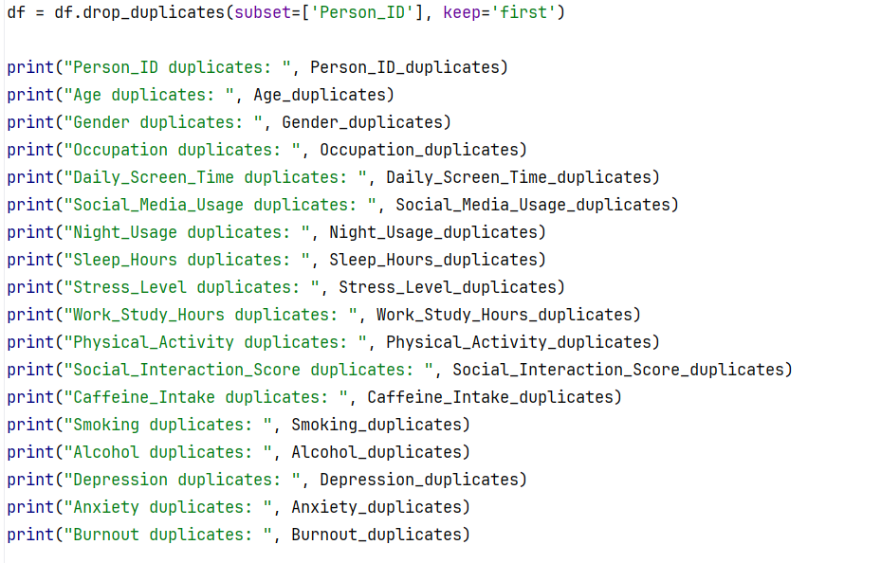

Output:
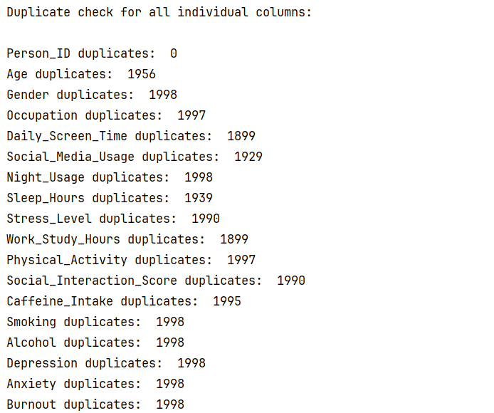

Missing Value Check
For missing values, I used Python's .isnull() and .count() to count missing values in each column. There were no missing values. The dataset is full.

Code:
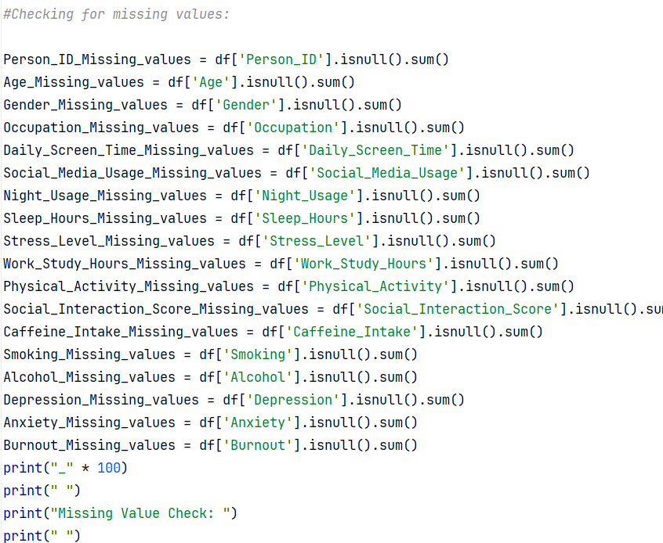
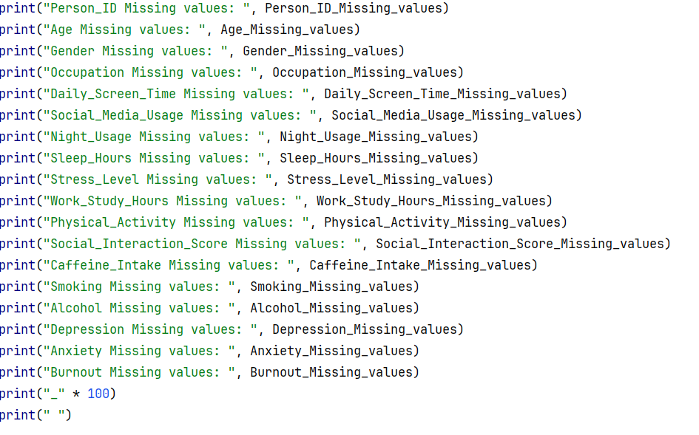

Output:
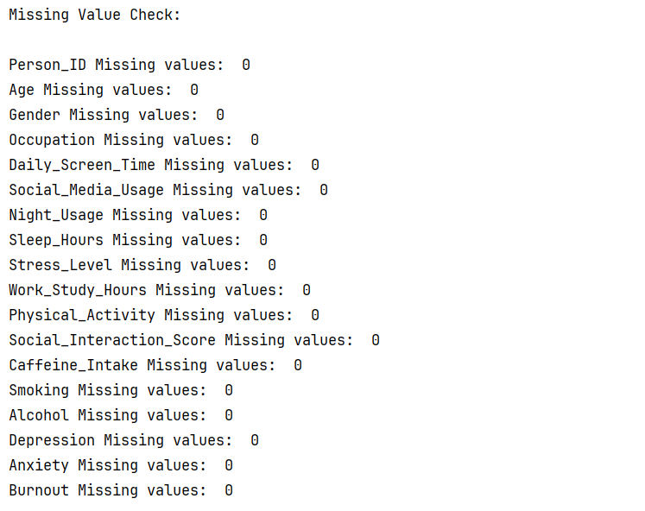

Inconsistencies Check
To address inconsistencies, I focused on columns containing string/text fields to streamline potential user errors. For example, in a dataset, user input errors are common, such as misspellings or variations in spelling with _ or spaces. As an analyst, one is supposed to normalize values to the most correct version to avoid skewing a dataset. Gender, Occupation, and Physical Activity were the columns I chose, and I used the Python .unique function to identify possible inconsistent values. After running the code, the dataset quality control passed, since the values were already normalized.

Code:
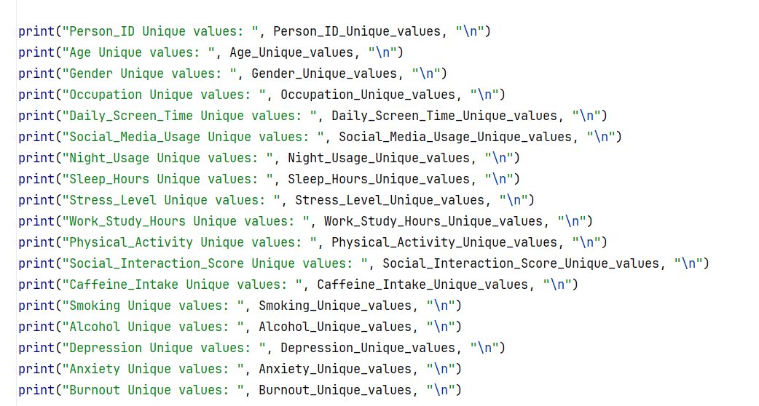

Output:
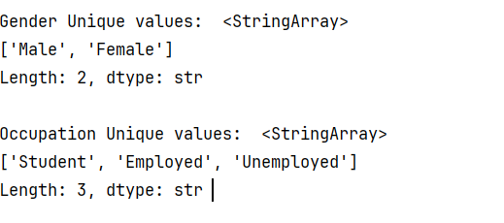
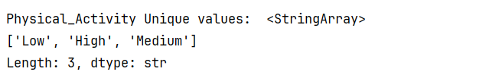

Formatting Error Check
To properly run analysis on a dataset, the analyst must avoid formatting mistakes that can cause columns with data to produce inconsistent results. Special characters such as @ or $, among others, can cause Python to classify an entire column as an object type rather than a numerical one, thereby preventing the use of values for statistical analysis. I ran the .info() method in Python to verify each data type per column. The dataset passed the QA check, as each numerical value was properly listed alongside the string objects.

Code:

Output:
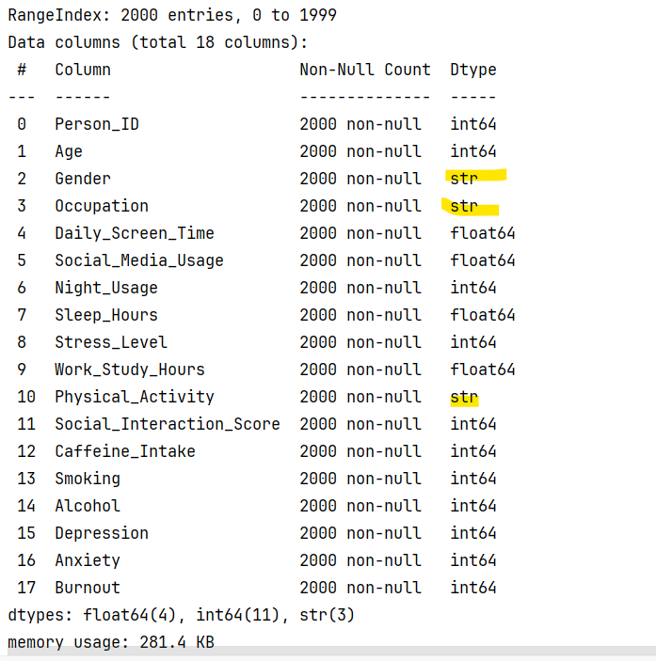

Outlier Check

I checked for outliers using the IQR method on all the numerical variables like Sleep_Hours, Daily_Screen_Time, and Stress_Level. After calculating the bounds, the results showed 0 outliers for every single column. Since all the data falls within the 1.5x IQR range and the min/max values actually make sense for a mental health survey, I didn't have to drop any rows. The dataset passed the outlier check with 100% of the data kept for the project.

Code: 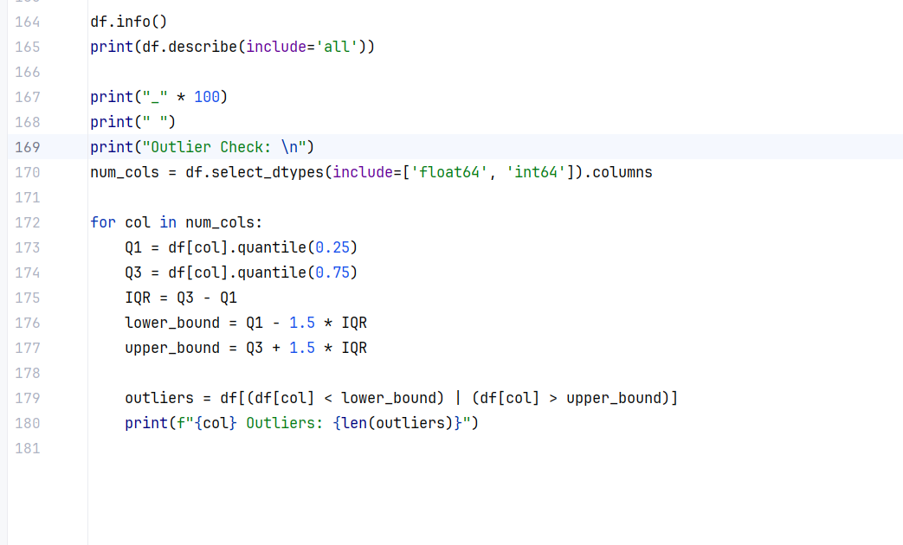

Output:
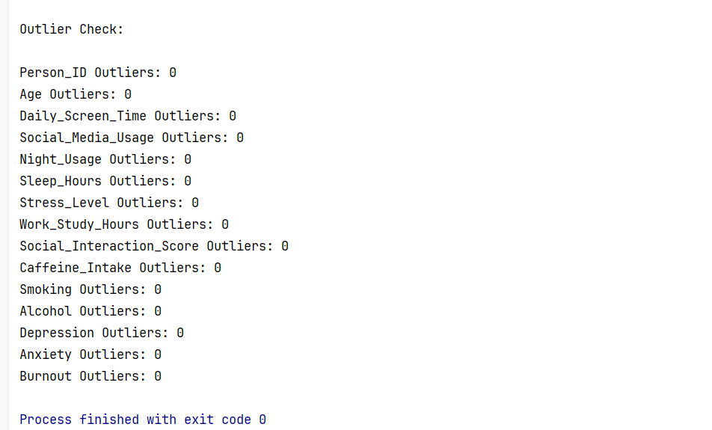

Conclusion:
After finishing the QA process, the dataset is fully cleared for analysis. I verified that there are zero duplicates in the Person_ID column and no missing values at all, so I didn't have to worry about dropping rows or filling in gaps. The data types are all correct and the string values were already normalized, which means there aren't any weird formatting issues or typos that would mess up the results later. Plus, since the IQR check showed zero outliers, I can move forward with 100% of the data kept. Overall, the dataset is clean and ready to go for the visualization phase.

